Audience profiles 1

Articles 3

Lessons 4

# Audience profiles

We can split our audience into four groups on the basis of their technical proficiency in artificial intelligence. Each group has different motivations for joining the club and will engage with different parts of our offering. We can tailor our offerings to appeal to these different groups.

We have **non-technical** people, who are not familiar with software or artificial intelligence technology. We have **AI beginners**, who are familiar with computer technology and are learning about AI technologies for the first time. We have **AI intermediates**, who are familiar with the basics of AI technology and its applications. Finally, we have **AI advanced** students, who are familiar with AI in theory and have some experience applying it in commercial or research settings.

Here’s a comparison of the different people in our audience:

|  |  |  |  |  |
| --- | --- | --- | --- | --- |
|  | Non-technical | Beginner | Intermediate | Advanced |
| Name | Jenny | Johnny | Jamantha | Joeseph |
| Degree | Finance, science, commerce | Compsci, SEng, economics, finance, mathematics, data science | Compsci, SEng, mathematics, data science | Compsci, mathematics, data science |
| Computer tech knowledge | None | Basic | Advanced | Advanced |
| AI theory knowledge | None | None | Basic | Intermediate or advanced |
| AI engineering knowledge | None | Basic | Basic | Basic or intermediate |
| Educational motivations | DISCOVER  - Learn about an impactful new technology  - Learn where the new tech can be applied  - Learn how the tech can help them at work/school | EXPLORE  - Understand what AI is  - Understand how AI impacts their field  - Apply AI for the first time  - Find resources for further exploration  - Meet people with similar interests | LEARN  - Learn basic AI theory  - Learn how to use AI in their field  - Understand the demands of AI implementations  - Get experience designing and implement AI for simple problems  - Learn from peers  - Compete in competitions | IMPLEMENT  - Learn intermediate to advanced AI theory  - Apply AI in realistic use cases  - Learn and apply advanced AI techniques  - Learn from peers  - Collaborate to build bigger projects  - Compete in competitions |
| Pains | - Difficult to understand the technology due to hype  - Resources are too technical  - Lacking a knowledgeable source to guide exploration | - Unclear how to discover the current impact of AI in their field  - Difficult to get started applying AI due to technical requirements  - Too many resources available, unclear where to start  - Lacking mathematical or computer science background to go deeper  - Not enough motivation to learn: overwhelmed or unsure about value | - No practical experience means it’s hard to get into the more advanced topics  - Missing the mathematical background needed to go deeper  - Not enough motivation to learn: overwhelmed or unsure about value | - Lacking some mathematical or computer science background  - Has some experience but not sure what to do next  - Not sure whether to focus on engineering or theoretical side of the technology |

Anecdotally, our audience distribution might look like this:

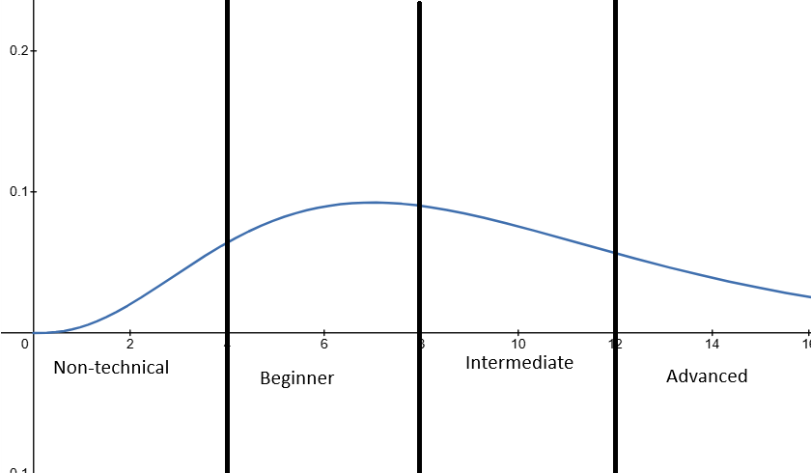

# Articles

* Target one of the four audience categories.
  + Mixing audiences will make the article less appealing to all categories.
  + Include extension and prerequisite knowledge if you need (see below).
* Speak to your audience.
  + Consider what is relevant to them (see the table above) and deliver that.
  + Non-technical people => no jargon, talk more about the economy and applications.
  + Advanced people => go into the nitty gritty.
* Give your article a descriptive title, a ‘hook’ in the first line, and a picture at the top.
  + These help attract readers, so your articles get read.
* Include plots and graphics through the article to explain points.
  + Vision helps your audience understand your explanations and learn your content.
* Give extension and prerequisite knowledge in your articles.
  + Inline if it’s brief, 1-2 sentences. This allows readers to read quickly to refresh their knowledge.
  + Dedicated section if it’s longer, paragraphs. This allows readers to read the information only if they need to.
  + Links to external resources if it’s a lot of knowledge or not the main focus of the article. This allows readers to get a proper brief and saves you time, but should be minimised as people are more likely to skip your article than read the links.

# Lessons

Teaching is really difficult, so don’t be afraid if you feel a bit lost! Here are some resources to help:

* The 5 principles of highly effective teachers
  + <https://www.youtube.com/watch?v=_jdTtnWMLVM>
* The public speaking lesson you never had
  + <https://www.youtube.com/watch?v=xSp78RwcAS4>
* Computer Scientist Explains Machine Learning in 5 Levels of Difficulty (ie how to speak to your audience)
  + <https://www.youtube.com/watch?v=5q87K1WaoFI>

Some general principles :

* Start every lesson with a set of aims/objectives and a personal introduction. It’s also a good time to ask the audience where they’re at with the content
  + Gets everyone ready to learn the content and helps people feel more confident in you
* Speak to your audience
  + See link above
* Ask your audience questions regularly
  + Helps audience understanding
  + Helps you get a feel for where the audience is at
* Mix abstract theory with concrete examples
  + This helps people understand the theory and justify its applications
* Include practical exercises
  + Great for engagement!
* Include references and links to further resources on the more challenging topics
  + Helps students push themselves and focus their learning